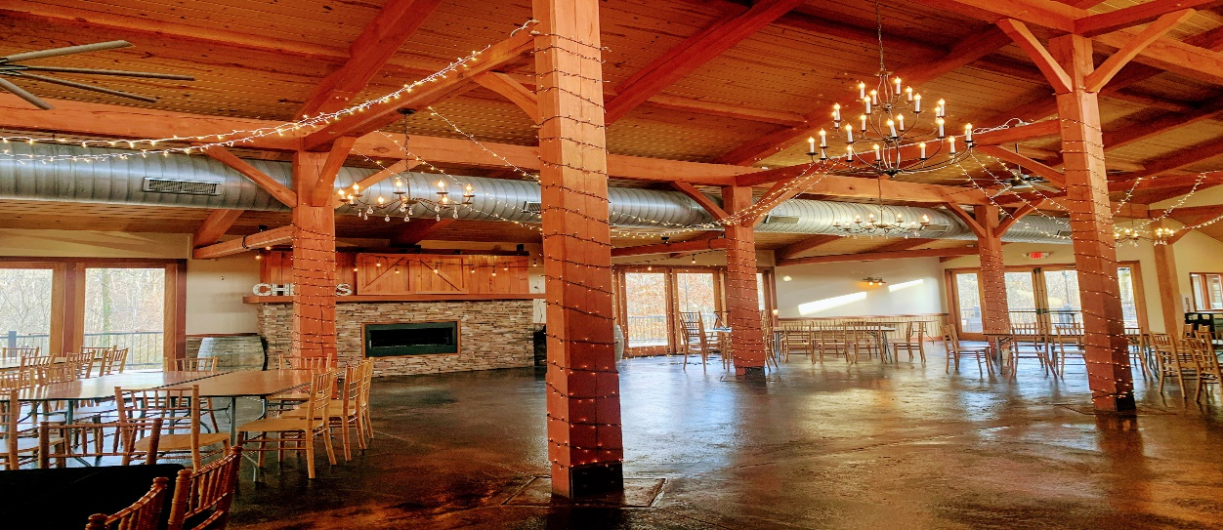Private Rooms Available:
-Our private spaces make the perfect setting for any event under 55 persons, a memorable and unique option for birthdays, anniversaries, bridal showers, community, or corporate style functions.
-Banquet room pricing: $400 minimum, each additional hour is $200.
-Barn rental pricing: $4,000 for 4 hours minimum, each additional hour is $1,000.
- Tables and chairs provided, as well as table linens with choice of ivory or navy. Events can be rented out between the hours of 11am-9pm. Additional hours may be purchased if desired. For catering options and availability please email us at:
info@ashtoncreekvineyard.com or events@ashtoncreekvineyard.com 